// Program using Exception

**package** com.java.demo;

**import** java.io.File;

**import** java.io.FileInputStream;

**import** java.io.IOException;

**public** **class** Exception {

**public** **static** **void** findFile() **throws** IOException {

File newFile = **new** File("test.txt");

FileInputStream stream = **new** FileInputStream(newFile);

}

**public** **static** **void** main(String[] args) {

**try** {

*findFile*();

}

**catch** (IOException e) {

System.***out***.println(e);

}

}

}

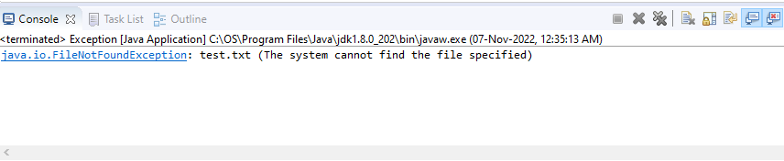

**package** abc;

**public** **class** Exception2 {

**public** **static** **void** main(String args[])

{

**try** {

**int** num1 = 100, num2 = 0;

**int** result = num1 / num2; // divide by zero

System.***out***.println("Result = " + result);

}

**catch** (ArithmeticException e) {

System.***out***.println("ArithmeticException:Division by Zero");

}

}

}

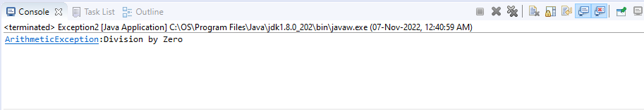

----------------------------------------------------------------------------------------------------------------

**package** abc;

**public** **class** Exception3 {

**static** **void** func(**int** a) **throws** Exception{

System.***out***.println(10/a);

}

**public** **static** **void** main (String[] args) {

**try**{

*func*(10);

*func*(0);

}**catch**(Exception e){

System.***out***.println("can't divide by zero");

}

}

}

